Here are the results to our Halloween
Costume Contest!
…and the winners are!...
The Funniest Costume – Yuewei (Dinosaur) – 10 votes
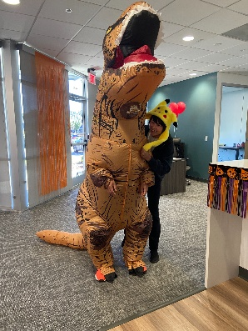
The Cutest Costume – Kathy (Mushroom) – 8 votes
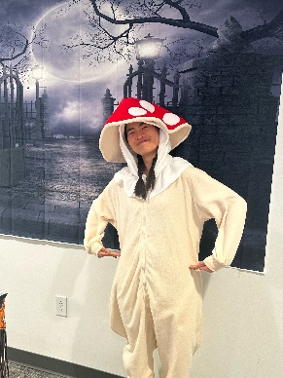
The Scariest Costume – TIE! –
Wanping (Masked Lady) – 6 votes
Carlie (Pennywise) – 6 votes
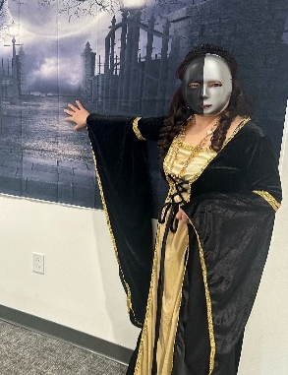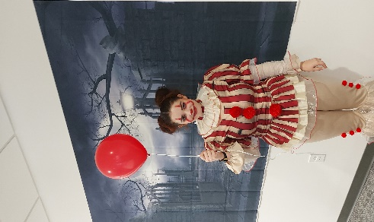
Thanks to all who participated in the Halloween fun and dressed up for our 1st Halloween Costume Contest! Everyone looked great and it will truly be a Halloween to remember.
Congrats to our winners!
*Prizes will be chosen in order of highest score during lunch.

